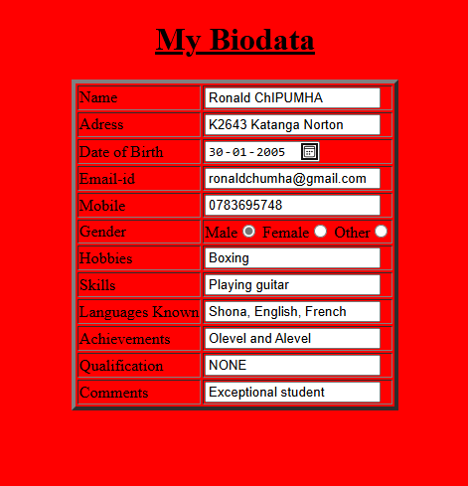
CODE
<!DOCTYPE html>
<html lang="en">
<head><title>Biodata</title>
<style>
body{background-color: red; font-weight: 200; border-color: rgb(0, 255, 0);
font-family: 'Courier New', Courier, monospace;
}

</style>
</head>
<body>
<h1 align="center"><u>My Biodata</u></h1>
<table align="center" border="4">
<tr>
<td>Name</td>
<td><input type="text"></td>
</tr>
<tr>
<td>Adress</td>
<td><input type="text"></td>
</tr>
<tr>
<td>Date of Birth</td>
<td><input type="date"></td>
</tr>
<tr>
<td>Email-id</td>
<td><input type="email"></td>
</tr>
<tr>
<td>Mobile</td>
<td><input type="number"></td>
</tr>
<tr>
<td>Gender</td>
<td>Male<input type="radio" name="Gender" id="Male" value="Male">
Female<input type="radio" name="Gender" id="Female" value="Female">
Other<input type="radio" name="Gender" id="Other" value="Other"></td>
</tr>
<tr>
<td>Hobbies</td>
<td><input type="text" ></td>
</tr>
<tr>
<td>Skills</td>
<td><input type="text"></td>
</tr>
<tr>
<td>Languages Known</td>
<td><input type="text"></td>
</tr>
<tr>
<td>Achievements</td>
<td><input type="text"></td>
</tr>
<tr>
<td>Qualification</td>
<td><input type="textbox"></td>
</tr>
<tr>
<td>Comments</td>
<td rowspan="2"><input type="textarea"></td>
</tr>

</table>
</body>
</html>

